ASSIGNMENT – 3

1. Select all open incidents.

select \* from Crime where status="open";

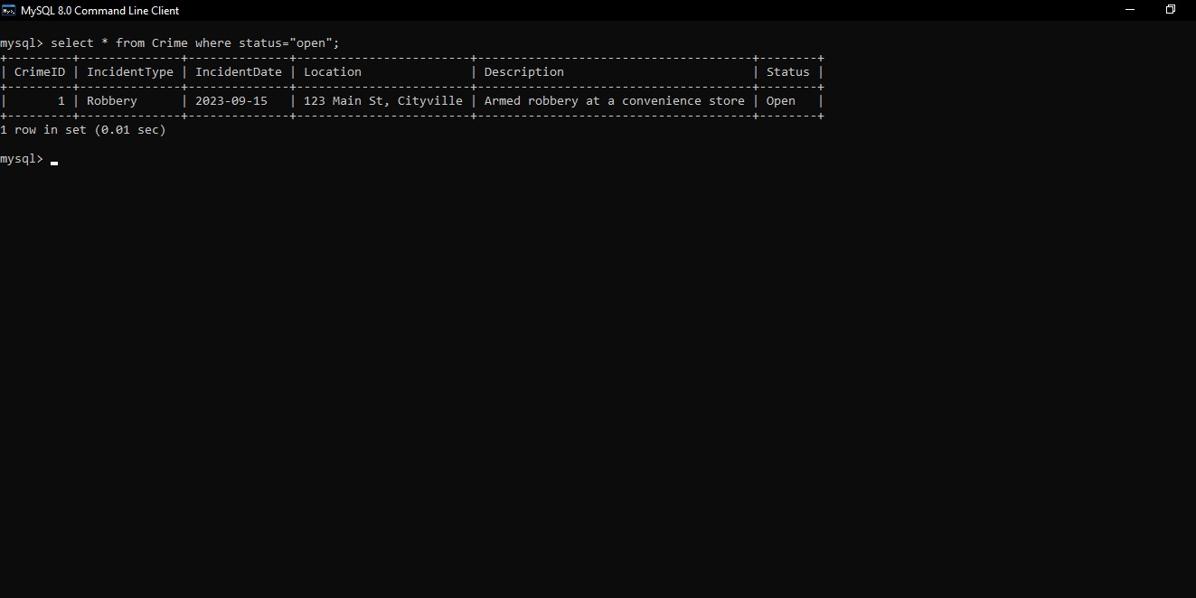

1. Find the total number of incidents

select count(IncidentType) from Crime;

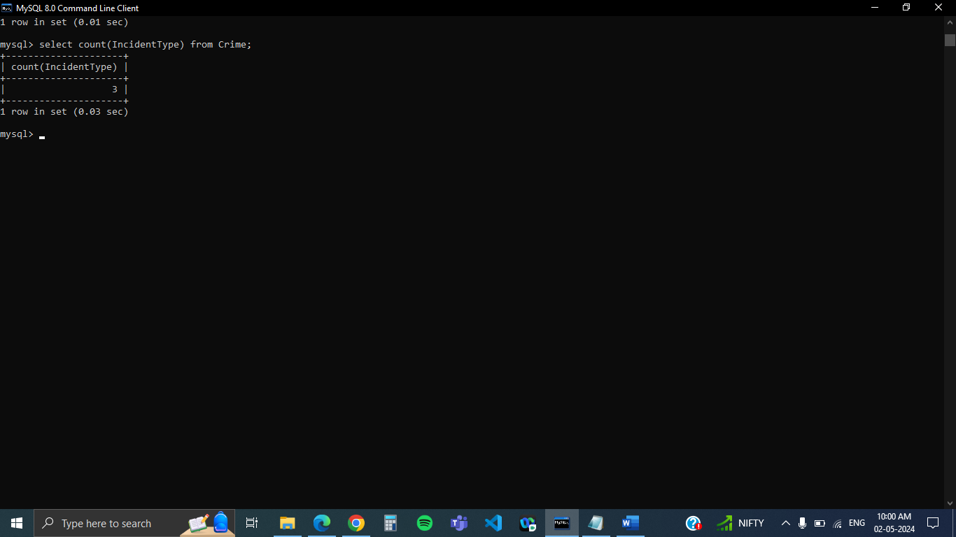

1. List all unique incident types.

SELECT DISTINCT IncidentType from Crime;

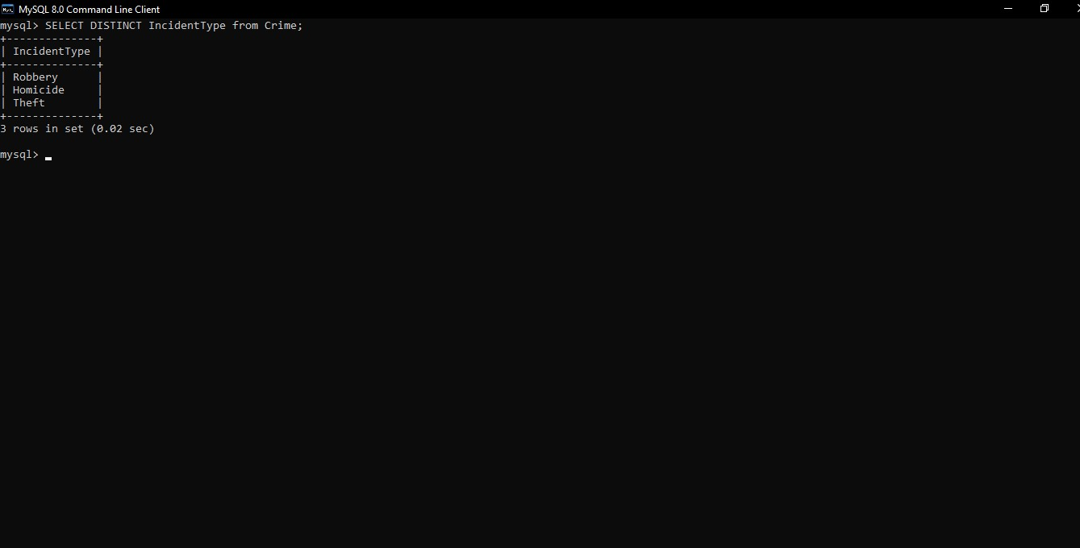

1. Retrieve incidents that occurred between '2023-09-01' and '2023-09-10'

select IncidentType from Crime where IncidentDate between '2023-09-01' and '2023-09-10';

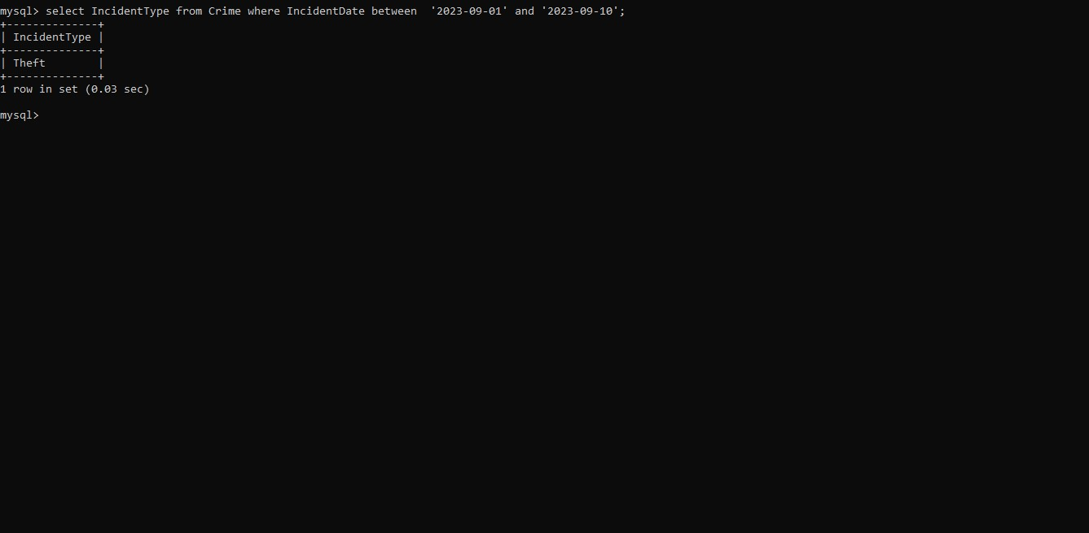

1. List persons involved in incidents in descending order of age.

select Name ,age from Crime,Suspect where Crime.CrimeID=Suspect.CrimeID order by age desc;

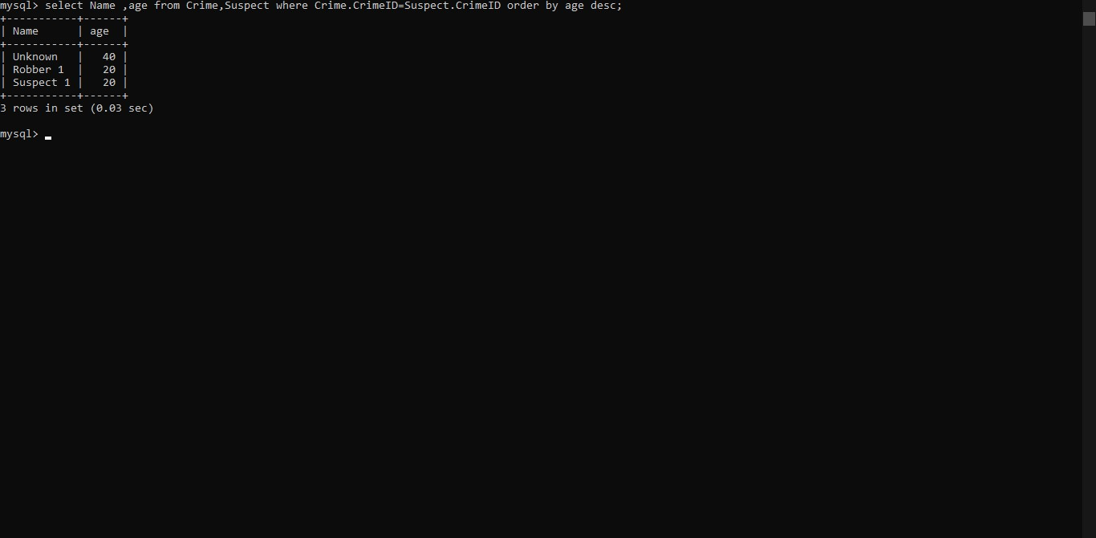

1. Find the average age of persons involved in incidents.

select avg(age),Name from Crime,Suspect where Crime.CrimeID=Suspect.CrimeID group by Name;

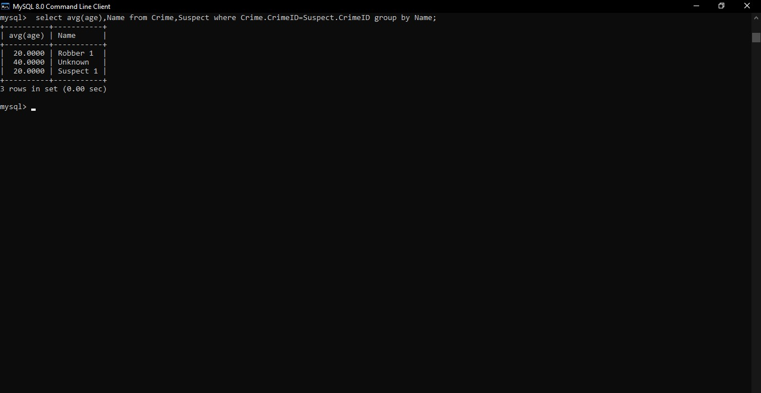

1. List incident types and their counts, only for open cases.

select count(IncidentType),IncidentType from Crime where status="open" group by IncidentType;

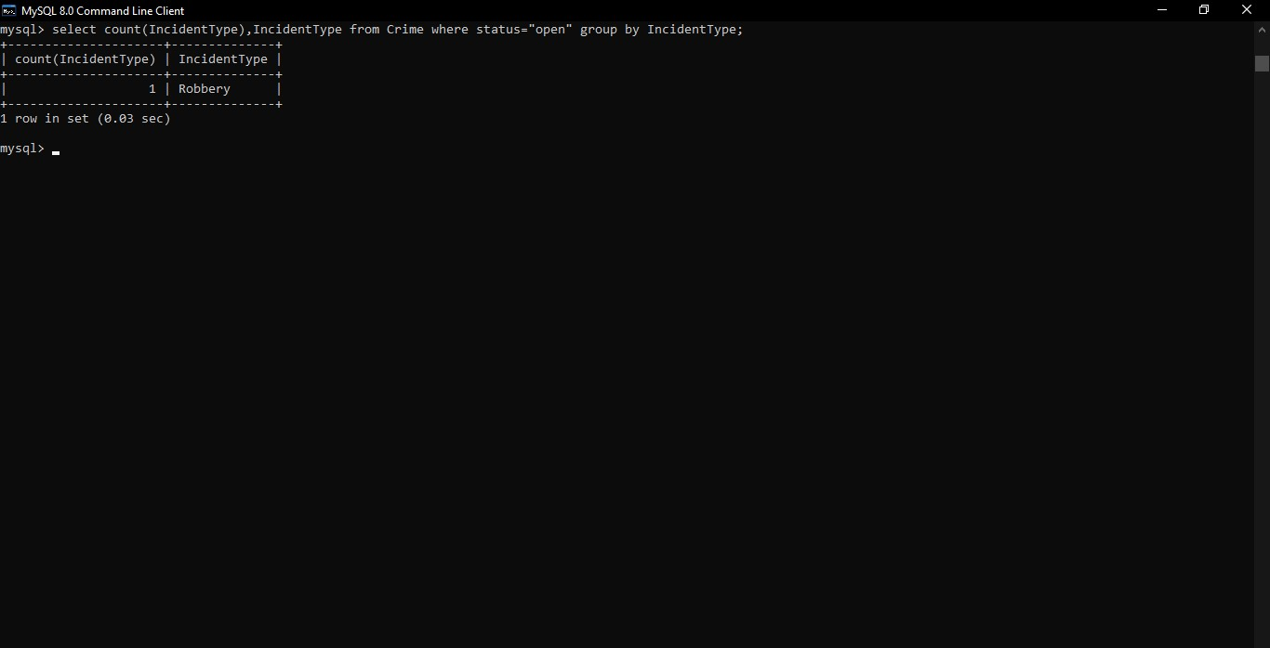

1. Find persons with names containing 'Doe'.

select Name from Victim where Name like "%Doe%" ;

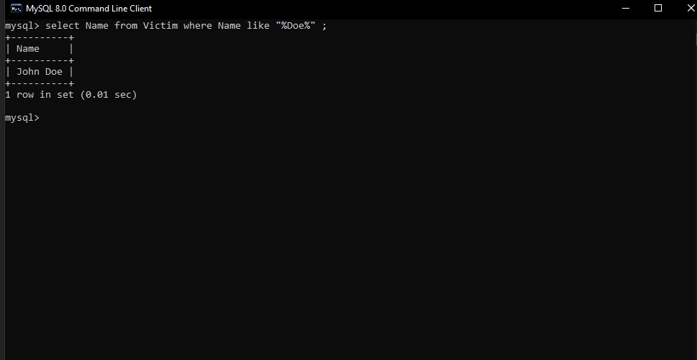

1. Retrieve the names of persons involved in open cases and closed cases

select Name ,Status from Crime JOIN Victim ON Crime.CrimeID=Victim.CrimeID where status IN("open","closed");

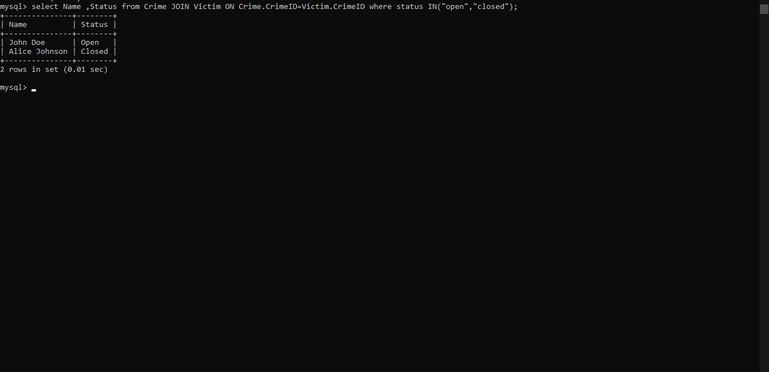

10. List incident types where there are persons aged 30 or 35 involved.

select IncidentType,age from Crime where age IN(30,35);

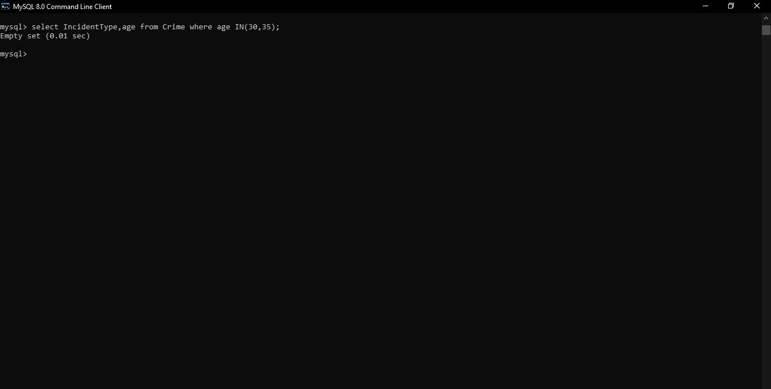

11 . Find persons involved in incidents of the same type as 'Robbery'.

select IncidentType,Name from Crime JOIN Victim ON Crime.CrimeID=Victim.CrimeID where IncidentType="Robbery";

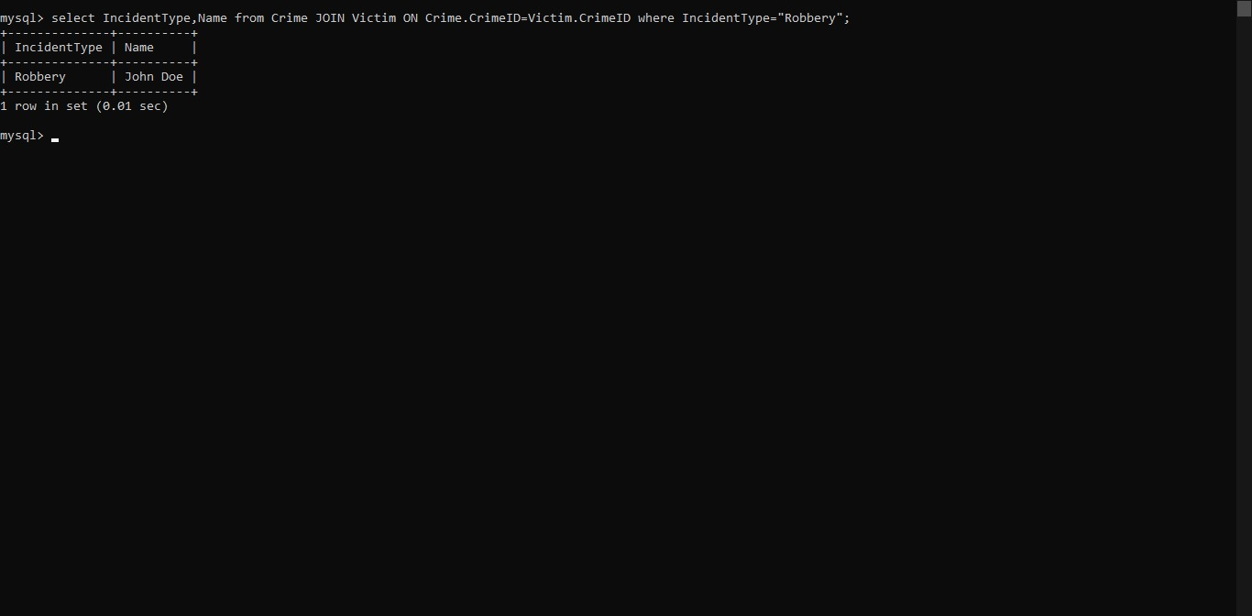

12. . List incident types with more than one open case.

SELECT IncidentType FROM (SELECT IncidentType, COUNT(\*) AS OpenCases FROM Crime WHERE Status = 'Open' GROUP BY IncidentType) AS IncidentCounts WHERE OpenCases > 1;

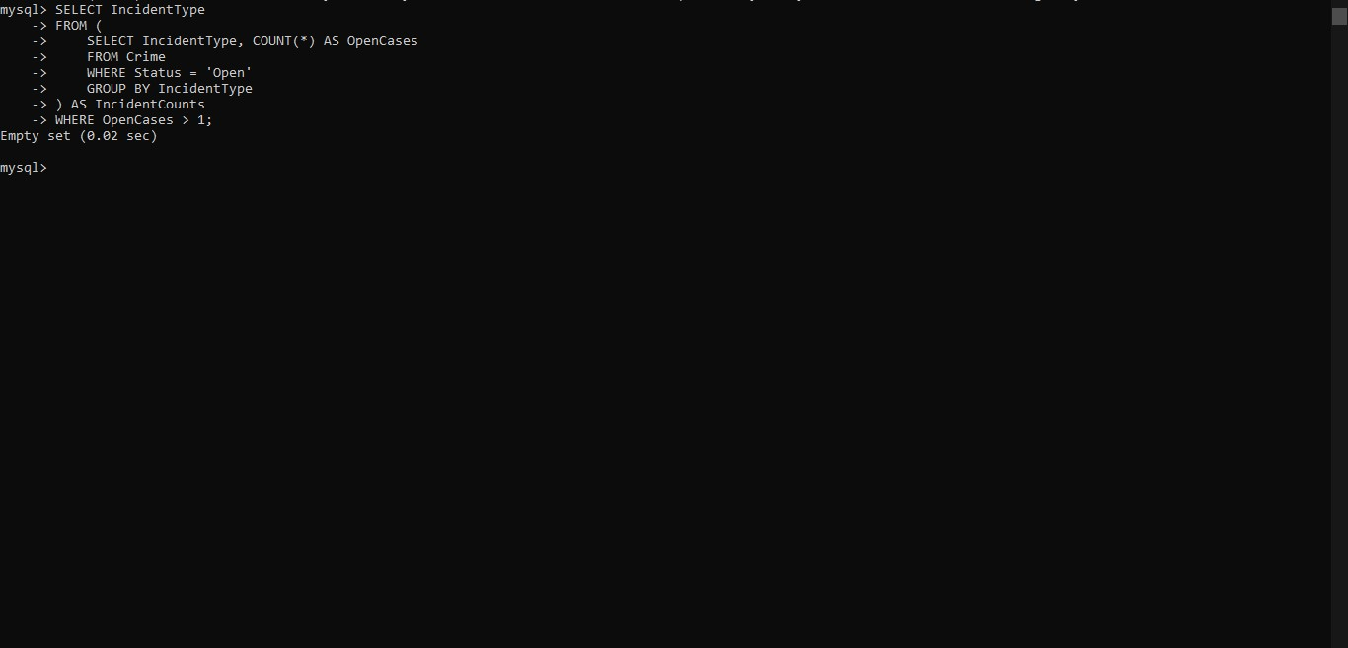

13. List all incidents with suspects whose names also appear as victims in other incidents.

SELECT DISTINCT c.\* FROM Crime c INNER JOIN Suspect s ON c.CrimeID = s.CrimeID INNER JOIN Victim v ON s.Name = v.Name AND s.CrimeID!=v.CrimeID;

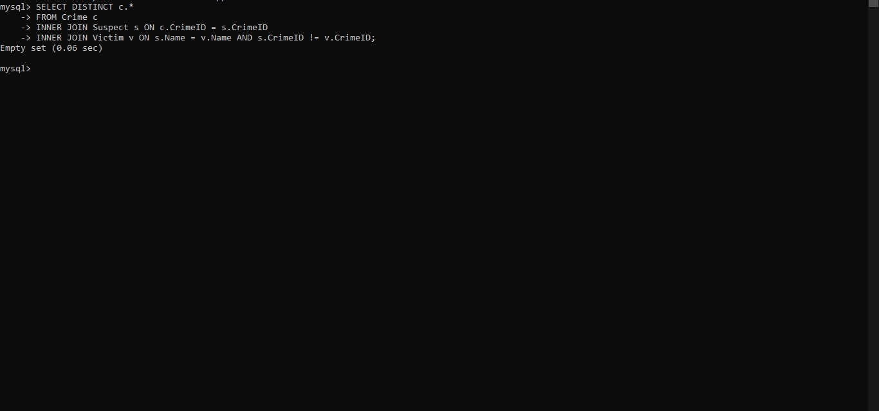

14. Retrieve all incidents along with victim and suspect details

SELECT c.\*, v.Name AS VictimName, v.ContactInfo AS VictimContactInfo, s.Name AS SuspectName, s.Description AS SuspectDescription, s.CriminalHistory AS SuspectCriminalHistory FROM Crime c LEFT JOIN Victim v ON c.CrimeID = v.CrimeID LEFT JOIN Suspect s ON c.CrimeID = s.CrimeID;

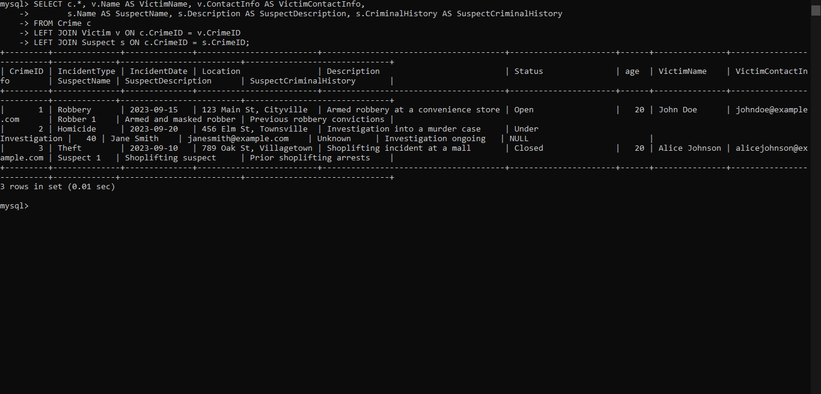

15. Find incidents where the suspect is older than any victim.

SELECT c.\* FROM Crime c JOIN Suspect s ON c.CrimeID = s.CrimeID LEFT JOIN Victim v ON c.CrimeID = v.CrimeID WHERE s.age > (SELECT MAX(age) FROM Victim WHERE CrimeID = c.CrimeID);

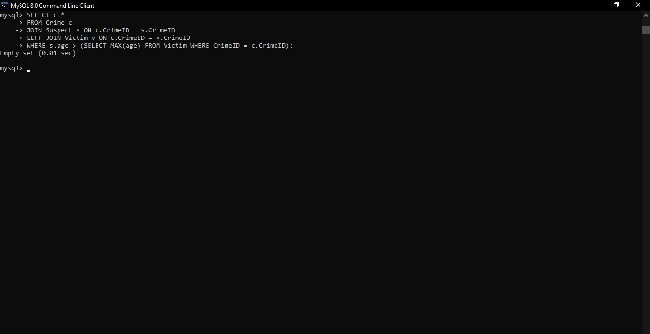

16. Find suspects involved in multiple incidents.

select Name,IncidentType from Suspect JOIN CRIME ON Suspect.CrimeID=Crime.CrimeID where IncidentType>1;

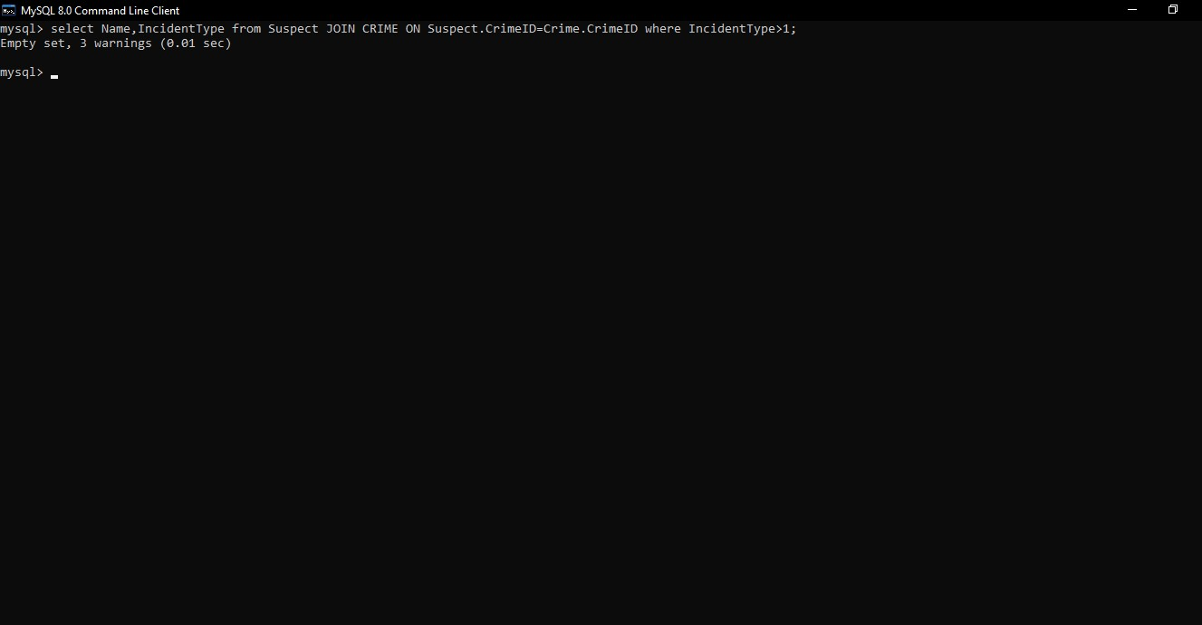

17. List incidents with no suspects involved.

select IncidentType,Name from Crime JOIN Suspect ON Crime.CrimeID =Suspect.CrimeID where SuspectID is null;

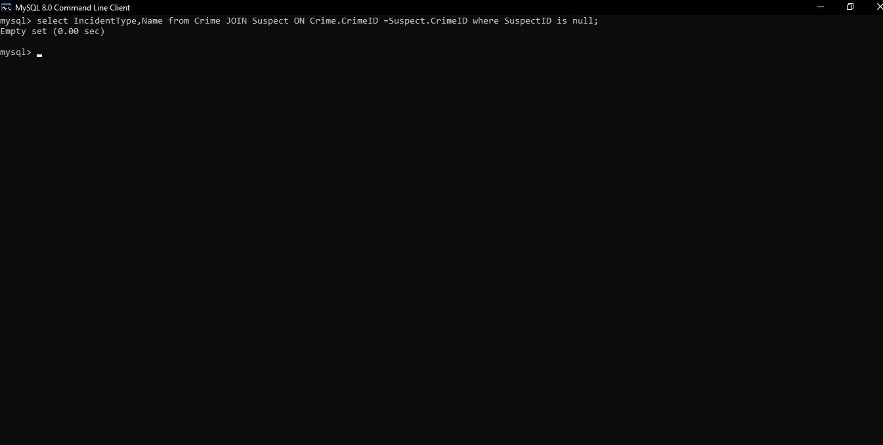

18. List all cases where at least one incident is of type 'Homicide' and all other incidents are of type 'Robbery'.

SELECT CrimeID FROM Crime WHERE IncidentType = 'Homicide' OR (IncidentType = 'Robbery' AND CrimeID NOT IN (SELECT CrimeID FROM Crime WHERE IncidentType = 'Homicide'));

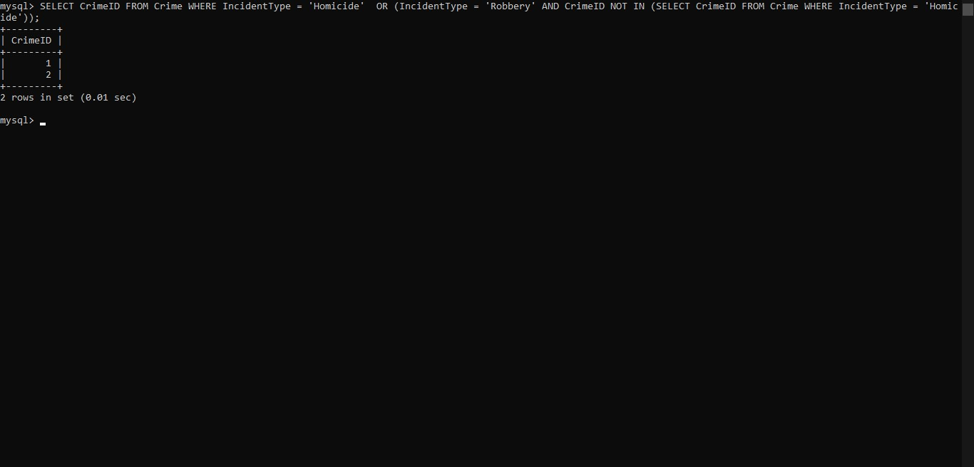

19. Retrieve a list of all incidents and the associated suspects, showing suspects for each incident, or 'No Suspect' if there are none.

SELECT c.CrimeID, c.IncidentType, s.Name AS SuspectName FROM Crime c LEFT JOIN Suspect s ON c.CrimeID = s.CrimeID;

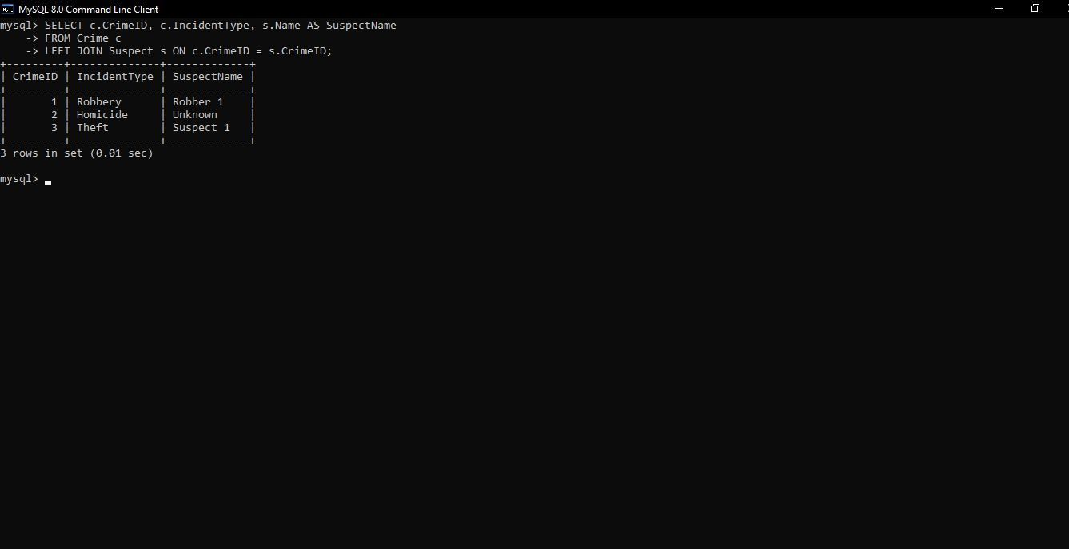

20. List all suspects who have been involved in incidents with incident types 'Robbery' or 'Assault.

Select Name,IncidentType from Suspect JOIN Crime ON Suspect.CrimeID=Crime.CrimeId WHERE IncidentType IN ( 'Robbery' ,'Assault');

